**DBMS PROJECT**

**ONLINE INVENTORY MANAGEMENT SYSTEM**

**Key Milestone 1**



## CSE403L Database Management System Lab

Group members

**Arsalan khan (22PWCSE2110)**

**Waseem (22PWCSE2179)**

**Adnan Zeb (22PWCSE2191)**

Class Section: **A**

“On my honor, as student of University of Engineering and Technology, I have neither given nor received unauthorized assistance on this academic work.”

Student Signature:

Submitted to:

## Engr.Sumayyea Salahuddin

(MAY 25, 2025)

Department of Computer Systems Engineering

University of Engineering and Technology, Peshawar

**ONLINE INVENTORY MANAGEMENT SYSTEM**

**Entity Description Table**

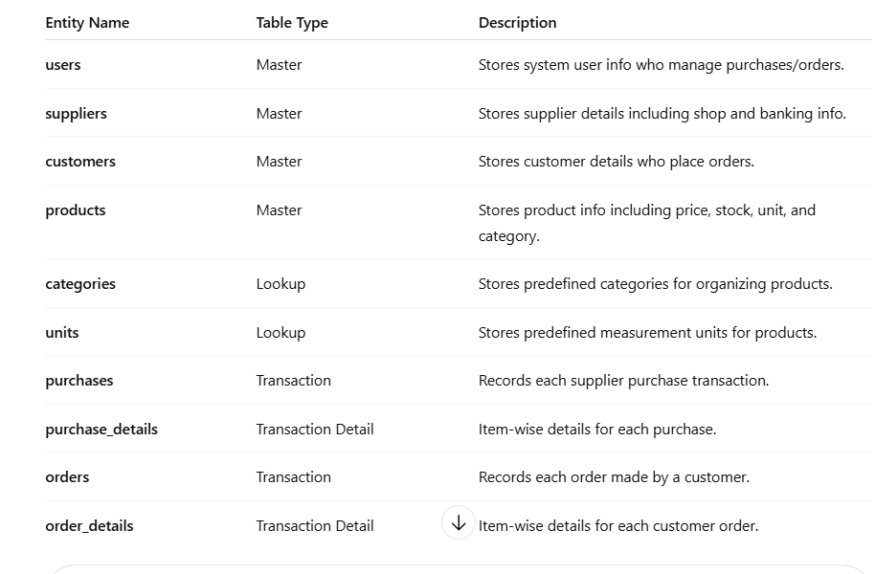

**Detailed Business Rules**

1. **Users** can create and update purchases. Each purchase stores who created/updated it.
2. **Products** must have one category, one unit, and a unique product code.
3. **Suppliers** can have many purchases. Each purchase must belong to one supplier.
4. **Purchases** must have at least one item in purchase_details. Product stock increases when purchased.
5. **Customers** can place multiple orders. Each order must be linked to one customer.
6. **Orders** must have one or more order_details. Product stock decreases when ordered.
7. **Prices**:
   * Products have buying and selling prices.
   * Totals: quantity × unit price.
   * Order total = subtotal + VAT.
8. **Payments**:
   * Orders store payment type, paid amount, and due amount.
   * If payment is partial, the remaining balance is due.
9. **Data Integrity**:
   * All foreign keys must reference valid records.
   * No deletion of customers, suppliers, or products if they are used in transactions.

**Entity Relationship Diagram (ERD)**

#### **1. users**

* id (PK)
* name
* email
* username
* photo
* password

**2. suppliers**

* id (PK)
* name
* email
* phone
* address
* shopname
* type
* bank_name
* account_holder
* account_number
* photo

**3. customers**

* id (PK)
* name
* email
* phone
* address
* type
* bank_name
* account_holder
* account_number
* photo

**4. categories**

* id (PK)
* category_name

**5. units**

* id (PK)
* unit_name

**6. products**

* id (PK)
* product_name
* product_code
* buying_price
* selling_price
* stock
* product_image
* category_id (FK) → categories.id
* unit_id (FK) → units.id

**7. purchases**

* id (PK)
* purchase_date
* purchase_no
* purchase_status
* supplier_id (FK) → suppliers.id
* created_by (FK) → users.id
* updated_by (FK) → users.id

**8. purchase_details**

* purchase_id (FK, PK) → purchases.id
* product_id (FK, PK) → products.id
* quantity
* unitcost
* total

**9. orders**

* id (PK)
* order_date
* order_status
* total_products
* sub_total
* vat
* total
* invoice_no
* payment_type
* pay_int
* due_int
* customer_id (FK) → customers.id

**10. order_details**

* order_id (FK, PK) → orders.id
* product_id (FK, PK) → products.id
* quantity
* unitcost
* total

**Relationships**

* **One-to-Many:**
  + users → purchases
  + suppliers → purchases
  + customers → orders
  + orders → order_details
  + purchases → purchase_details
  + products → purchase_details / order_details
  + categories → products
  + units → products

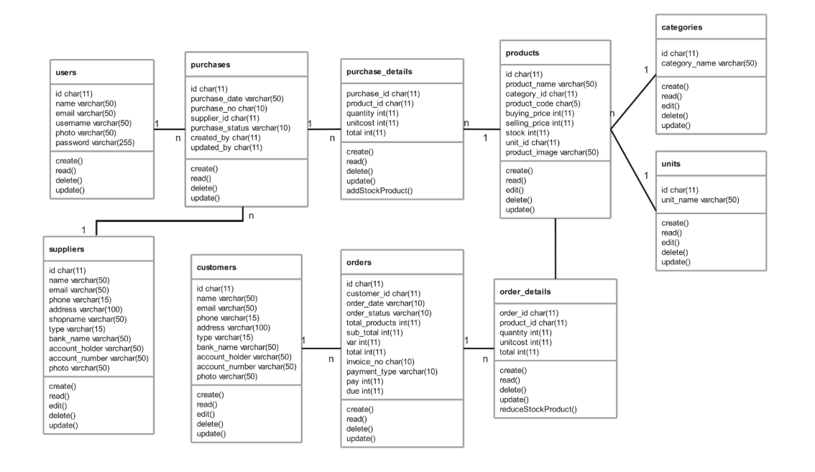

**Enhanced Entity Relationship Diagram (EERD)**

**users**

* id (PK), name, email, username, password

**suppliers**

* id (PK), name, contact info, bank info

**customers**

* id (PK), name, contact info, bank info

**categories**

* id (PK), category_name

**units**

* id (PK), unit_name

**products**

* id (PK), name, code, prices, stock
* category_id (FK), unit_id (FK)

**purchases**

* id (PK), date, supplier_id (FK), created_by (FK)

**purchase_details**

* purchase_id (FK), product_id (FK), quantity, unitcost, total

**orders**

* id (PK), date, customer_id (FK), total, payment info

**order_details**

* order_id (FK), product_id (FK), quantity, unitcost, total

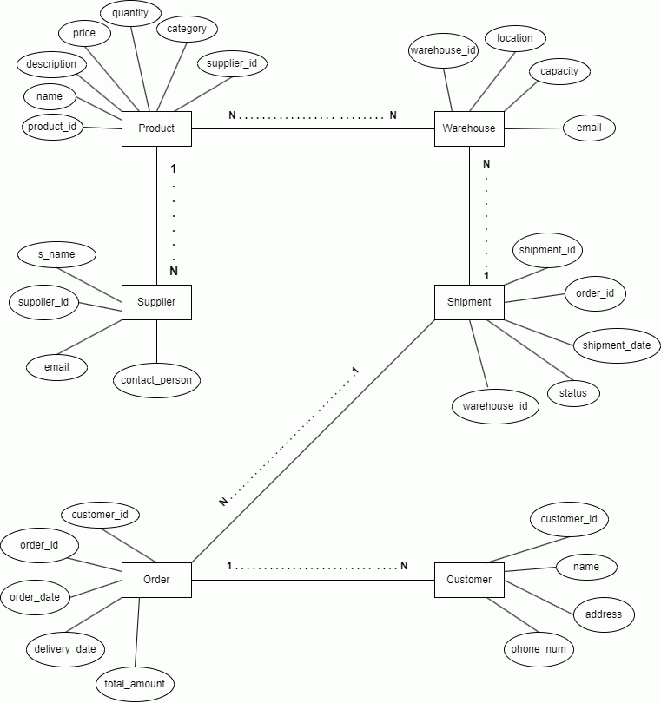

**References**

https://chatgpt.com/c/68332bf2-96a0-800e-a887-ace82ab513a5

<https://chatgpt.com/c/68334e0d-b7dc-800e-ba3b-555c7904535c>

https://github.com/fajarghifar/inventory-management-system